Main Screen

1. The pickup and dropoff address textbox both need two taps before the keypad opens up. Please check the issue.

* done
* 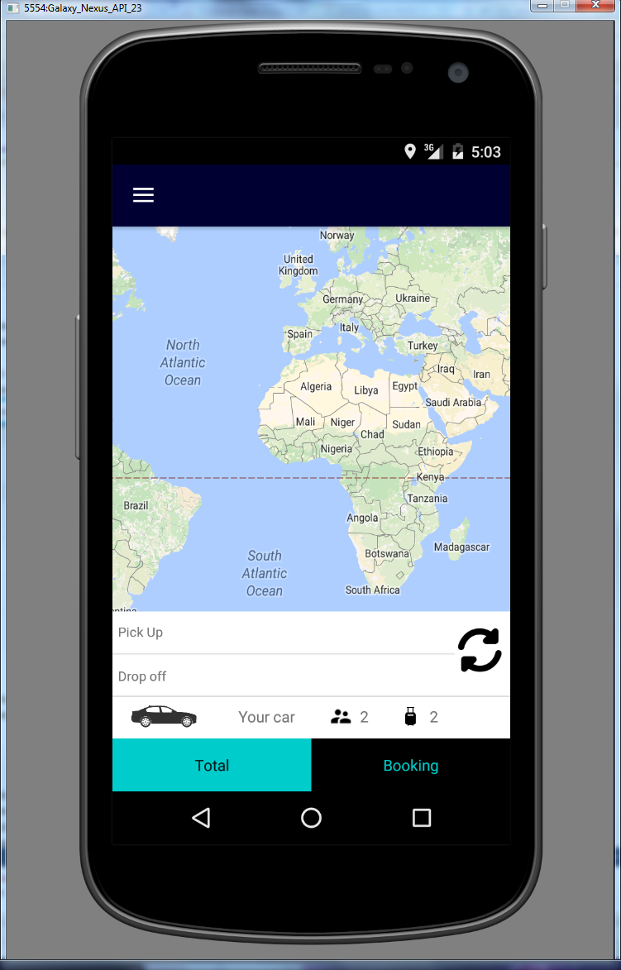
* 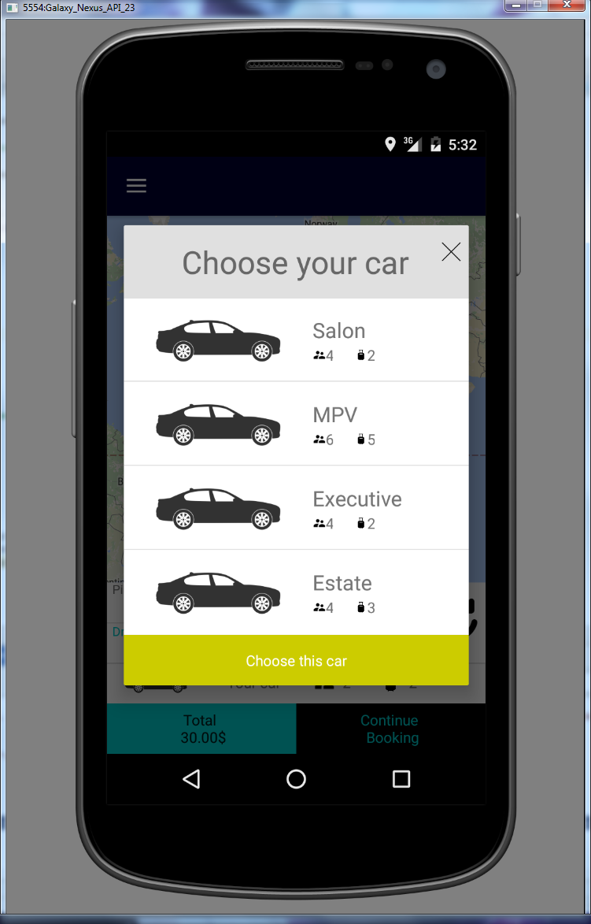
* please give me the icons soon.

1. Limit the frequently used address to maximum 5. Can you divide the autocomplete dropdown into three sections like below:

-Home Address (1)

* not yet design

-Nearby Addresses (5) – Check the previous documentation for endpoint

* not yet

-Frequently Used Addresses (5)

* I just set a viriable to set frequently number

**private static final** Integer ***FREQUENTLY_NUMBER*** = 5;

1. The quotation seems to be always $30. As soon as both addresses are available quotation needs to requested and displayed. The quotation needs to be invalidated as soon as any of the address changes.

Logcat :

* Json String : {"bags":0,"bookingdate":"0001-01-01T00:00:00","childseat":null,"custid":0,"doff":null,"doffLat":51.319804,"doffLong":-0.140841,"droppostcode":null,"executive":null,"note":null,"paq":0,"petfriendly":null,"pick":null,"pickLat":0.0,"pickLong":0.0,"pickpostcode":null,"returndate":null,"rtnType":null,"via":null,"viaLat":null,"viaLong":null,"viapostcode":null}
* return : {"RoutePath":[],"AdditionalInfo":"3/29/2016 10:28:41 AM: String parsed.\r\n3/29/2016 10:28:41 AM: Checking Fixed Price.\r\n3/29/2016 10:28:41 AM: Veh Type.1\r\n3/29/2016 10:28:41 AM: Checking surcharge.\r\n3/29/2016 10:28:41 AM: Error in surcharge.\r\n","code":0,"message":"System.NullReferenceException: Object reference not set to an instance of an object.\r\n at EiinarCustWebApi.Controllers.QuotationController.RetrieveQuote(Int32 custid, String pick, Double pickLat, Double pickLong, String doff, Double doffLat, Double doffLong, String via, Nullable`1 viaLat, Nullable`1 viaLong, DateTime bookingdate, Int32 paq, Int32 bags, String note, Nullable`1 returndate, String rtnType, Boolean childseat, Boolean petfriendly, Boolean executive, String pickpostcode, String droppostcode, String viapostcode)","vehTypeID":1,"rtn_routedistance":0.0,"routedistance":0.0,"rtn_traveltime":0.0,"traveltime":0.0,"vehType":"Saloon","totalfare":null,"fare":null,"returnfare":null,"viaLat":0.0,"viaLong":0.0,"doLat":0.0,"doLong":0.0,"pkLat":0.0,"pkLong":0.0,"bookingRef":null,"InServiceArea":false}
* Please let me know which field is required and how to send data success.

Booking screen

1. If the customer clicks the ‘+’ button next to the dropoff address then a new textbox needs to be appended below it. It will be called ‘via address’.

* I’m going to add a new edit text and when we click on it, we can pick up the via address

1. With any address/datetime changes the quotation needs to be recalled.

* functions quotation fail

1. On ‘confirm booking’ button click the app crashes. Please check the log for more information.

* done
* 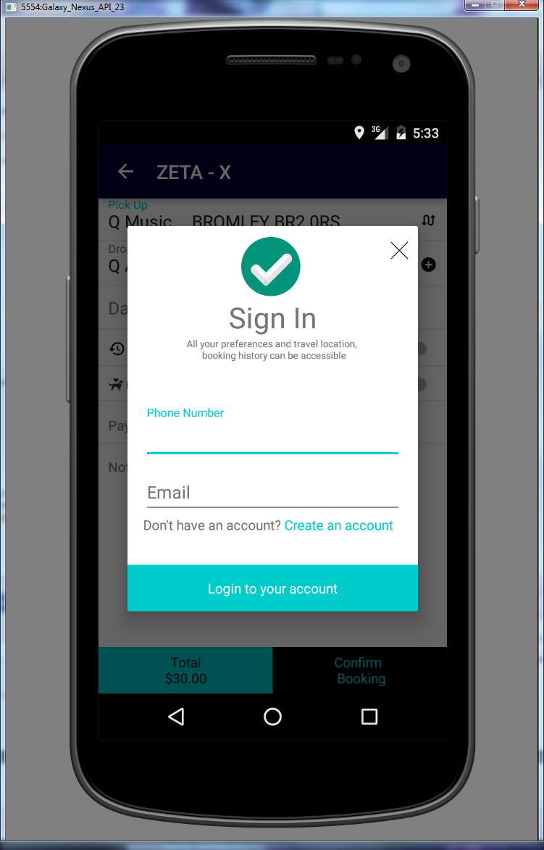

1. Don’t worry about the payment section now. Let’s assume all are ‘cash’ booking.

Navigation Drawer

1. This menu needs to be on top of the textboxes on the bottom of the page.

* done
* 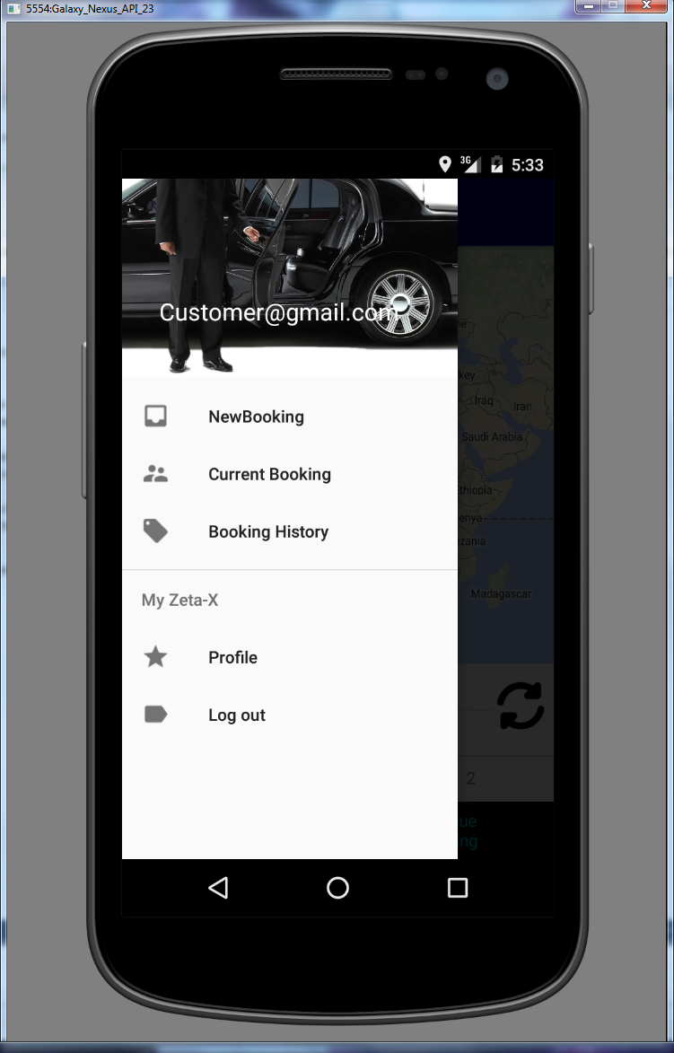

1. ‘Current bookings’, ‘Booking History’ and ‘Profile’ needs to be kept hidden until the customer logs in.

* not yet

1. If there are no bookings/history then the customer needs to be prompted and brought back to the main screen.

* not yet design

Let’s do these. Then we will look into more.